Question 1:

Create a class Employee(Empid, name, salary) which will get stored in the form of singly linked list.Do below operations on it.

1. Insert the employee at any postion.

2. Search an employee in the linked list using employee name.

3. Display all the data. [15 Marks].

Question 2:

Implement insertion sort for array of 10 integers. [15 Marks]

Show sorted array after every iteration.

Question 1:

# Create binary search tree for below given numbers.

# 50 20 10 56 87 76 45 98 4 18

# Perform below Tree traversals.

# 1. Inorder

# 2. Preorder(non recursive)

# 3. PostOrder [15 Marks]

# Question 2:

# Create Linear Queue using array to store characters. Write menu driven program to do essential functionalities of the queue. [15 Marks]

Question 1

Create singly circular linked list of n nodes and write two functions as per below.

1. Function to count number of nodes of the linked list.

2. Function to do product of all the nodes in the linked list. [15 Marks]

Question 2

Create menu driven program to implement stack using array .

Array must be created on heap.Push n elements to the stack and perform all essential operations on the stack. [15 Marks]

Question 1.

Write a class which accept information of Students and then perform following operation on them

a. Insert node into Singly linklist. (5 Marks)

b. Remove consecutive entries having same Student Name from given linked

list. (10 Marks)

c. Display detail of linklist. (5 Marks)

Student Detail

1. Name - String

2. RollNo - int

3. Grade - String

Question 2.

Here is an array of ten integers:

5 3 8 9 1 7 0 2 6 4

Draw this array after the FIRST iteration of the large loop in a selection sort (sorting from smallest to largest).

(10 Marks)

**Question 1**

Implement the following method as a new static method for the IntNode class. (Use the usual IntNode class with instance variables called data and link.)

Int count42 (IntNode head)

**Precondition:**

1. head is the head reference of a linked list.
2. The list might be empty or it might be non-empty.

**Post condition:**

The return value is the number of occurrence of 42 in the data field of a

node on the linked list. The list itself is unchanged. **(15 Marks)**

**Question 2**

Write a program to implement stack using link list and count the duplicities entries.

**(15 Marks)**

**Question 1**

Create a Binary Search Tree by inserting element from below tree .Then traverse the linked list in inorder() ,preorder () and postorder (). (20marks

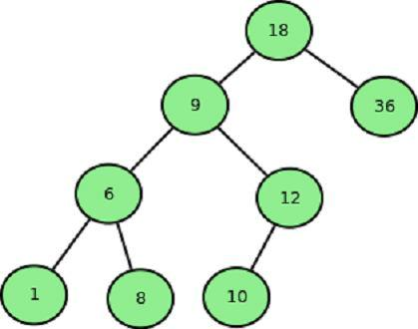

**Question 2**

Write a Program to input percentage of students from user and apply bubble sort to display marks in descending order. **(10 Marks)**

**QNo1.**

Implement the following method as a new static method for the IntNode class.

**Precondition:**

1. Head is the head reference of a linked list.

2. The list might be empty or it might be non-empty.

**Post condition:**

The return value is the product of all the data component of all the nodes.

NOTE: If the list is empty, the method returns 1.

Question 1:

Complete the body of this method. Use a CharQueue to store the input line as it is being read.. Use the method in.charInput() to read and return the next character of the EasyReader, and use in.isEOLN() to determine whether the next input charater is the end-of-line.

Public static int counter(EasyReader in)

**Precondition:**

1.There is a line of input waiting to be read from in.

2.Using Queue

**PostCondition:**

1.Line of input has been read from in, up to but not including the newline character. The return value of the method is the number of times that the last character of the line appeared somewhere in this line.

Example: input : ABBXDXXZX: the value returned by counter would be 4 for this input since there are 4 ‘X’ in the input line. **(20marks)**

Question 2:

Given two sorted integer arrays A and B, merge into A as one sorted array. **(10marks)**

Question 1:

Write a function to merge two linked lists.

**Post condition:**

1.The input lists have their elements in sorted order from smallest to highest.

2.The output list should also be sorted from highest to lowest. **(20 marks)**

Question 2:

Given a list of non negative intergers, arrange them such that they form the largest number. For example, given [3,30,3,5,9] the largest formed number is 9534330. (Note: the result may be very large, so you need to return a string instead of integer). **(10marks)**